UNIT TESTING REPORT

* We are using Cunit for testing purpose of file validation and validity of output printed in result.txt
* We have made various header files along with .c and main file. At the end we are using makefile to compile and run the program.

CUnit Testcases for file validation function:

* **3 Sunny testcases** (Valid input files) and **3 rainy testcases** (Invalid input files)

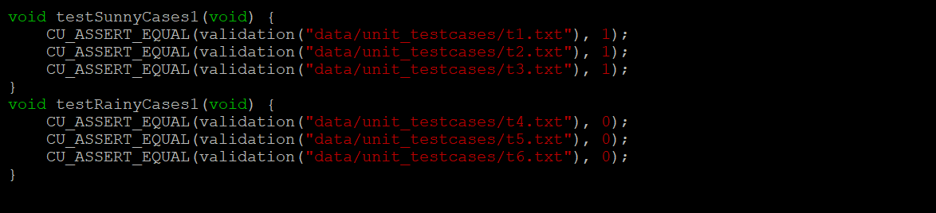

Cunit Testcases for checking validity of result function:

* **3 Sunny testcases** (Passing those keywords that are present in the file along with the exact number of occurrences) and **3 Rainy testcases** (Passing keywords that are not present in the file or passing incorrect number of occurrences or both)

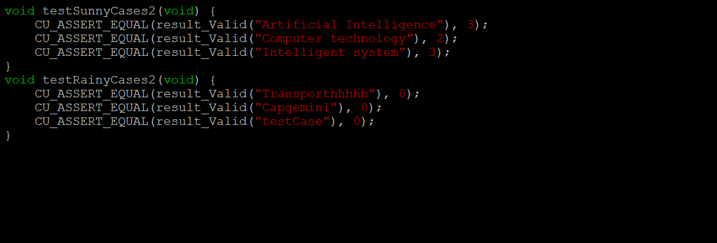

Execution as well as Running the program via makefile

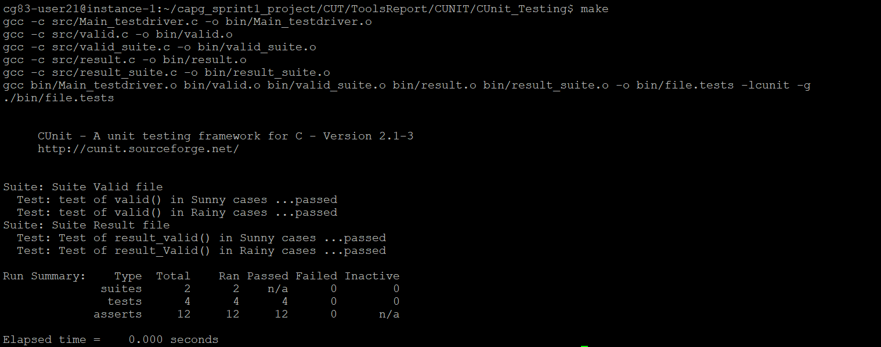

References:

The header files of both the valid function and result checking function is stored as header files in include folder. Programs are written in C language and stored as .c files along with the main.c in src folder. The object and executable files are stored in bin folder. We are using makefile to execute as well as run the program.